KSIS Registration, Tariff and Music Upload
WEBSITE - WWW.RGFORM.EU
The KSIS system will be utilized as the scoring system, tariff sheet, music upload and tariff sheet review. If your club has attended a competition that utilized KSIS, you already have a club login. If not, please register in KSIS by following the instructions below.
How to register on KSIS:
Go to the KSIS website: www.rgform.eu. In the upper right-hand corner, click on REGISTER (if you have not done so already) or LOGIN. To register a new club, fill out the form. A registration link will be sent to you via email. Then proceed to login.
Once you have logged in, click Events - Select Acrobatic Gymnastics under Virtual/Online Events, Scroll down and select the appropriate event name.
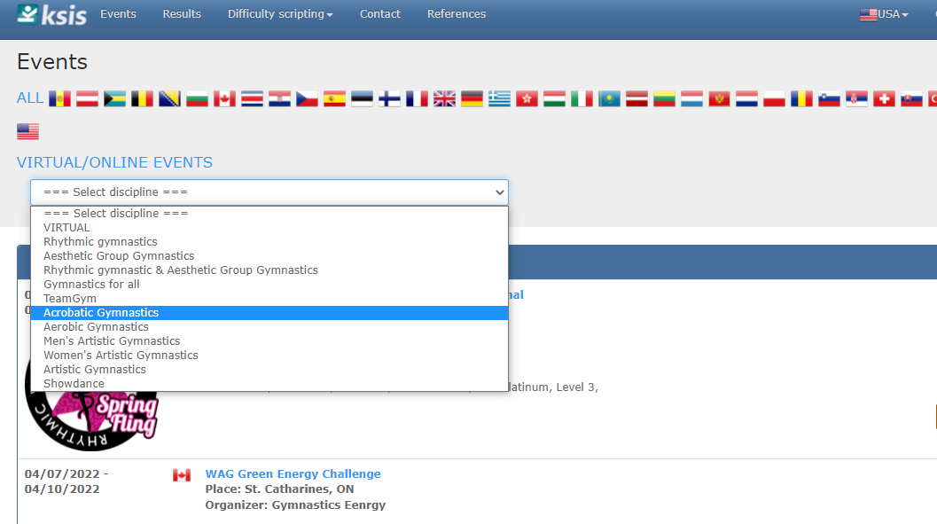
You will register all coaches, delegation officials, team managers and pair/groups under PRELIMINARY REGISTRATION. DO NOT ENTER INDIVIDUAL GYMNASTS. ONLY enter pair/groups in GROUPS. You will enter the gymnast’s individual information later.
KSIS will default the Club, Country and Email. You will need to enter the Contact Person. This is where you will enter all Pair/Groups, Coaches, Team Managers, Head of Delegation, Medical, Judges, etc.
Under Funct., select the GROUP function to register each pair/group. Click on Group Name. Next enter the first name followed by the family/last/sir name of each athlete in the pair/group. Separate each athlete’s name with a comma. This information will be used in the schedule and announcer scripts, so please make sure their full names are entered and spelled correctly. For the order of the names, please enter the top first, followed by middle(s), where applicable and then the base ie: Minnie Mouse, Mickey Mouse.
If the delegation is unsure of the pair/groups they are bringing, you can enter provisional information as follows: Mixed Pair 1, Women’s Group 3, etc. This will allow for the provisional entry to be recorded. You will then be able to enter exact participant information by the registration deadline.
You will select the CATEGORY from the Category drop down menu. Please make sure you double check this field. The schedule will be created based upon the category selected.
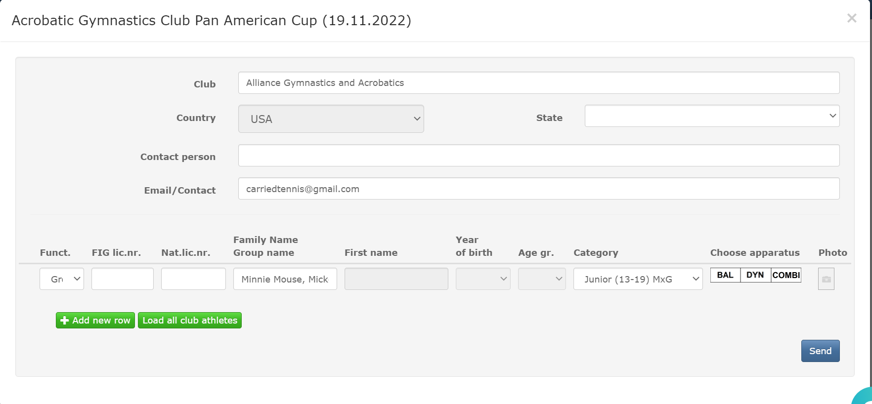Then, you can select +Add new row, to add the next pair/group. Repeat this process until all pair/groups are added.
Next, choose all applicable apparatus (routines: balance, dynamic, combined) that the pair/group is participating in.
Then click on the camera icon to add the group picture.
Once you have completed this process for all participants and groups, click on SAVE. This will save the delegation entries.
If you need to add additional entries later, you will repeat all of the steps above.

HOW TO ADD INFORMATION FOR EACH GYMNAST:
Login to KSIS: Go to the KSIS website: www.rgform.eu.
Click on the drop-down arrow under your name in the upper right corner. Select My entries. All added groups from Preliminary Registration will appear under My entries.
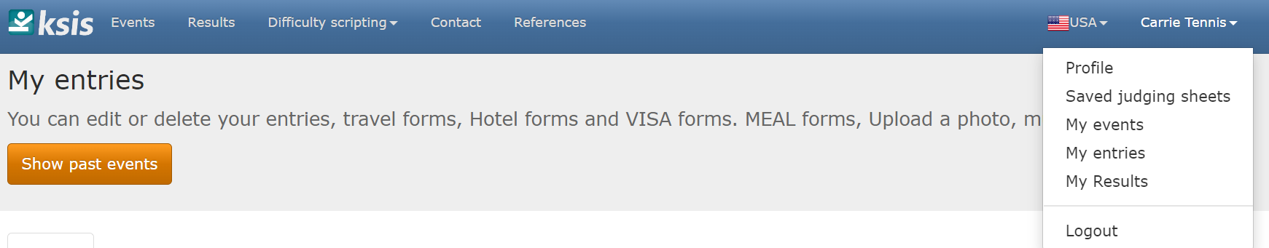
To add the gymnast’s information, tariff sheets, music, etc., click EDIT to the right of the pair/group in Entries. 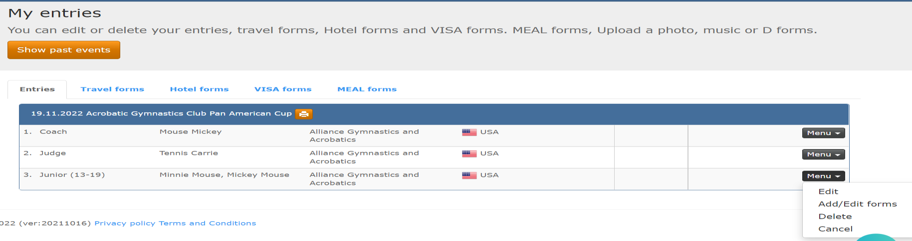
First, make sure the pair/group’s name is correct. Then add the contact information and coaches for the groups listed. Enter one or more coach’s names in the Coaches box, just make sure to separate each one by a comma.
Enter each individual gymnast’s information including FIG License Number, Family Name, First Name, Year, Month and Date of Birth, and Individual Photo.
Then, click on +Add Group Member to add additional members of the group. Add Tariffs (D-Forms) and Music using the GREEN + for the appropriate routine. Tariffs must be uploaded as PDF’s.
Music must be uploaded in MP3 format.
Once complete, click on SAVE to save the entry.

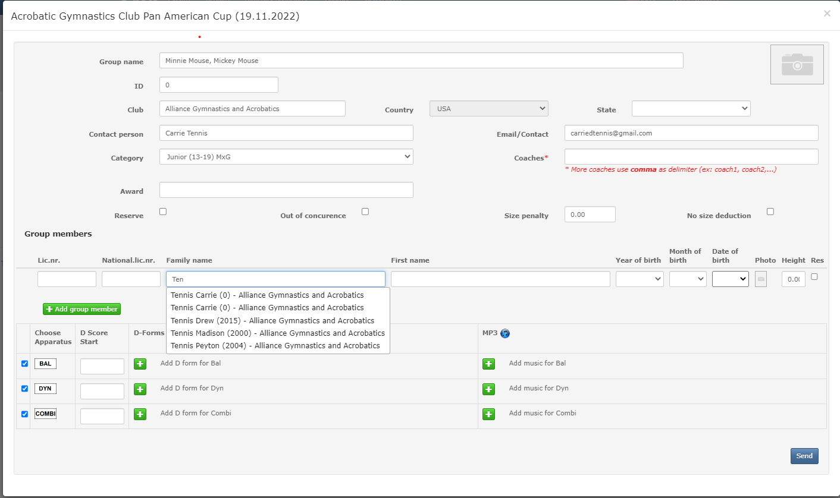
It is very important that you make sure all tariffs, music, individual athlete and pair group pictures are uploaded by the corresponding deadlines.
Any revisions will require a re-upload. To do this, you will delete the existing tariff by clicking on the “X” next to the appropriate document. Then you will be able to upload the revision. You must upload any revisions by the revision deadline. It is the responsibility of the CLUB to make sure that everything is correct. The final download will serve as the official tariff and music for the event.

